Feeding Pregnant Women

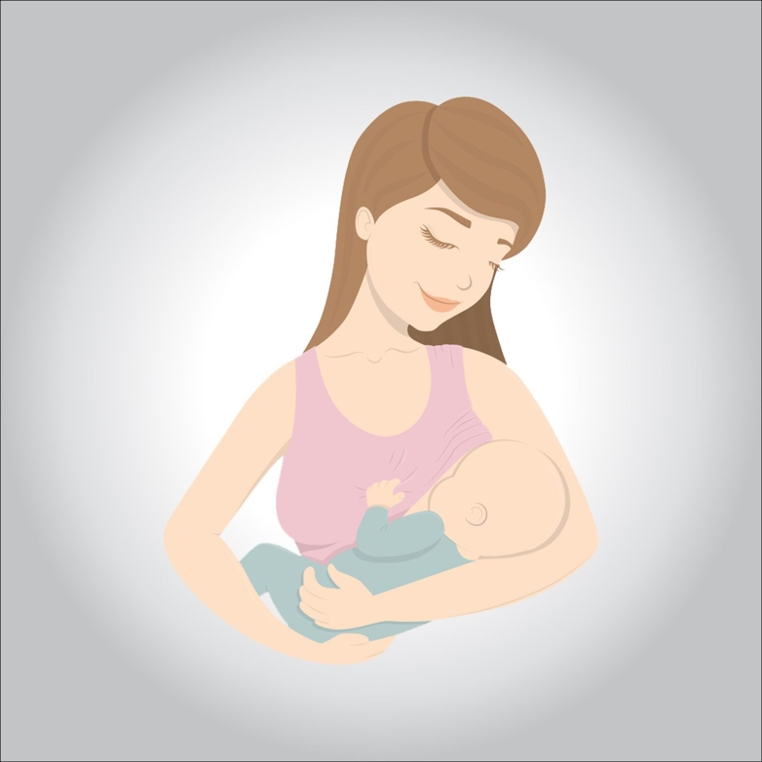

**Good nutrition is important during pregnancy to maintain the health of the mother and fetus, as the quality of food is more important than its quantity, so it is recommended to choose healthy foods of high nutritional value, and avoid unhealthyfoods.**

**The importance of good nutrition duringpregnancy:**

* **Building bones and blood cells for thefetus.**
* **Reduce pregnancy troubles andproblems.**
* **Strengthening immunity for the prevention of infectiousdiseases.**
* **Prevention of iron deficiencyanemia.**
* **Strengthening the body in preparation forchildbirth.**
* **Promoting milk formation forbreastfeeding.**

**Weight gain duringpregnancy:**

**Healthy weight gain varies depending on the mother’s BMI and health before pregnancy, if the BMI is normal, it is recommended to earn 11 to 15 kg duringpregnancy.**

**The impact of obesity onpregnancy:**

**If your BMI is higher than normal or reaches obesity, it negatively affects pregnancy, as women are more likely to develop the**

**followingproblems:**

* **Gestationaldiabetes.**
* **High bloodpressure.**
* **Pregnancypoisoning.**
* **Prematurebirth.**
* **Caesareansection.**

**In addition, newborns may develop the following problems:**

**Birth defects.**

**Large fetal size (gigantism), with the possibility of injuries during childbirth.**

**Childhood obesity.**

**Foodsrecommended:**

* **Proteins: It is recommended to obtain them from lean meats (e.g. chicken, fish, pulses, etc.) everyday.**
* **Carbohydrates (e.g. bread, cereals, potatoes, rice andpasta).**
* **Fat: It is recommended to obtain them from plant sources (e.g. olive oil), and to avoid saturated fats of animal origin (e.g.butter).**
* **Pasteurized dairy products: (e.g. yogurt, milk andcheese).**
* **Vitamins andminerals.**
* **Too muchfiber.**

**Foods toavoid:**

* **Avoid uncooked meat or eggs as they may contain listeria, which is transmitted to the fetus through the placenta causing miscarriage, or the birth of a deceasedfetus.**
* **Fish:**

1. **Avoid eating raw fish or uncooked oysters that may contain germs (bacteria, viruses or parasites).**
2. **Avoid certain fish species because they contain a high level of mercury that can damage the nervous system of the fetus (e.g. shark, swordfish,marlin).**
3. **Limit tuna intake and not more than four medium-sized cans (net weight = 140 grams per can) perweek.**
4. **Some types of oily fish that may contain chemicals from pollution, may accumulate in the body over time and be harmful, so it is recommended not to exceed two servings per week (e.g. mackerel, sardines, salmon and fresh tuna, where canned tuna is not considered oilyfish).**

* **Caffeine: A substance naturally found in foods (e.g. tea, coffee, chocolate), some soft drinks, energy drinks or some analgesics, is recommended to reduce intake during pregnancy, as it increases the risk of miscarriage and low child weight atbirth.**
* **Unpasteurized milk and all itsproducts.**

**Supplements:**

* **Goodsupplements:**

**üIron: To prevent the mother from developing iron deficiency anemia, in addition to helping to transfer blood to the largest amount of oxygen to thefetus.**

**üFolic acid: to prevent the fetus from developing cleftsteel.**

* **Harmfulsupplements:**

**üAvoid too much vitamin A, whether with food or supplements, because it can harm thefetus.**

**Supplements do not eliminate healthynutrition.**

**Foodpoisoning:**

**It is abdominal pain accompanied by diarrhea and vomiting, caused by a bacterial infection or bacteria in the stomach, and to avoid food poisoning is thereforerecommended:**

* **Cook food and meatwell.**
* **Wash fruits and vegetableswell.**
* **Keep the kitchen clean and the tools of eating andcooking.**
* **Wash your hands after exiting the toilets, before and after eating, after handling raw meat, after touching theanimals.**
* **Generalguidelines:**
* **Avoid fried foods and replace them withgrilling.**
* **It is recommended to eat well-washed fruits andvegetables.**
* **Avoid starting a diet to lose weight (diet) during pregnancy, as this affects the mother and child’s access to importantnutrients.**
* **Reducing salt in food, as it causes fluid retention, leading to high blood pressure**
* **Misconceptions:**
* **Pregnant women should be fed by twopeople.**
* **Fact: Pregnant women should focus on the quality of food that benefits their fetus and not on theirquantity.**
* **Stop eating caffeine (found in coffee, tea, etc.) duringpregnancy.**
* **Fact: It is required to be mitigated as much as possible, especially in the first trimester of your pregnancy, i.e. the first three months of fetalformation.**